**Hamza Mushtaq**

**Roll no 20F-1119**

**Task 1:**

Code:

<!DOCTYPE html>

<head>

<title>Lab task 1</title>

</head>

<body>

<h1>Name : Hamza Mushtaq</h1>

<h2>Roll No : 20F-1119</h2>

<p>Hi its me Hamza Mushtaq. </p>

</body>

</html>

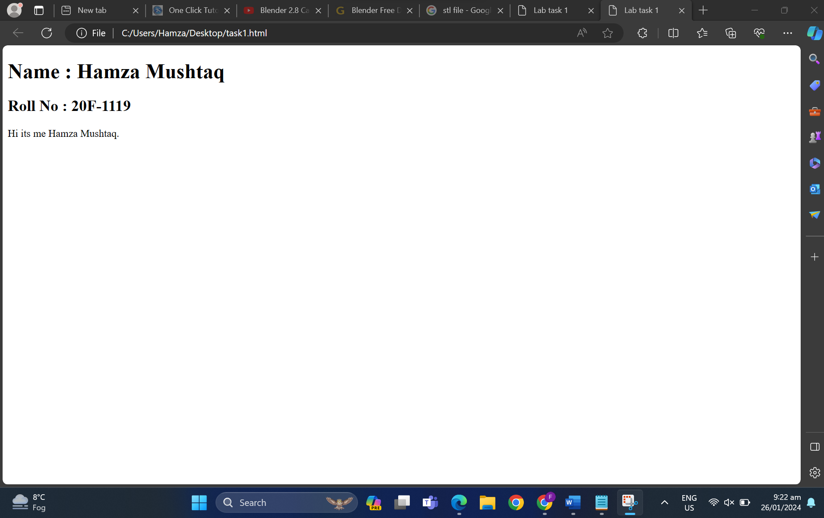

**Task 2:**

<!DOCTYPE html>

<head>

<title>Lab task 2</title>

</head>

<body>

<bold>This is bold text</bold>

<br>

<strong> This is strong text </strong>

<br>

<big>This is big text</big>

<br>

<i>This is italic text</i>

<br>

<em>This is emphasized</em>

<br>

<mark>This is computer output</mark>

<br>

<p>This is<sub>subscript</sub>and <sup>superscript</sup></p>

</body>

</html>

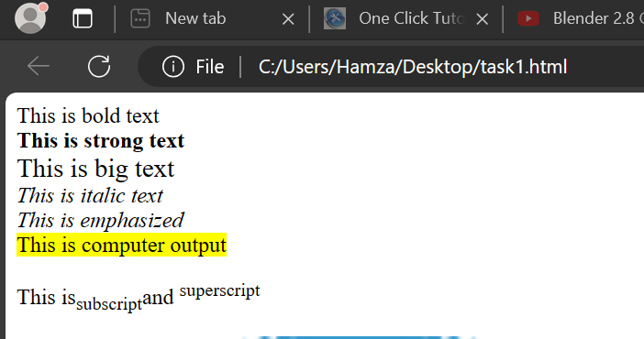

**Task 3:**

<!DOCTYPE html>

<head>

<title>Lab task 2</title>

</head>

<body>

<img src='download.png' alt="haha" width="500" height="500">

</body>

</html>



**Task 4:**

<!DOCTYPE html>

<head>

<title>Lab task 2</title>

</head>

<body>

<a href="https://www.nu.edu.pk.com" target="_blank">

<img src="download.png" alt="img">

</a>

</body>

</html>



**Task 5:**

<!DOCTYPE html>

<html >

<head>

    <meta name="viewport" content="width=device-width, initial-scale=1.0">

    <title>List Example</title>

</head>

<body>

<h1>HTML Lists<h2>

    <h2>Unordered List</h2>

<p>     We have books on a variety of languages  </p>

    <ul>

        <li>Oracle</li>

        <li>Java</li>

        <li>HTML</li>

        <li>CSS</li>

    </ul>

    <h2>Ordered list </h2>

    <p>Follow these Steps to install Java:</p>

    <ol>

        <li>Download the software </li>

        <li>Extract a folder</li>

        <li>Double click the executable to run</li>

    </ol>

</body>

</html>

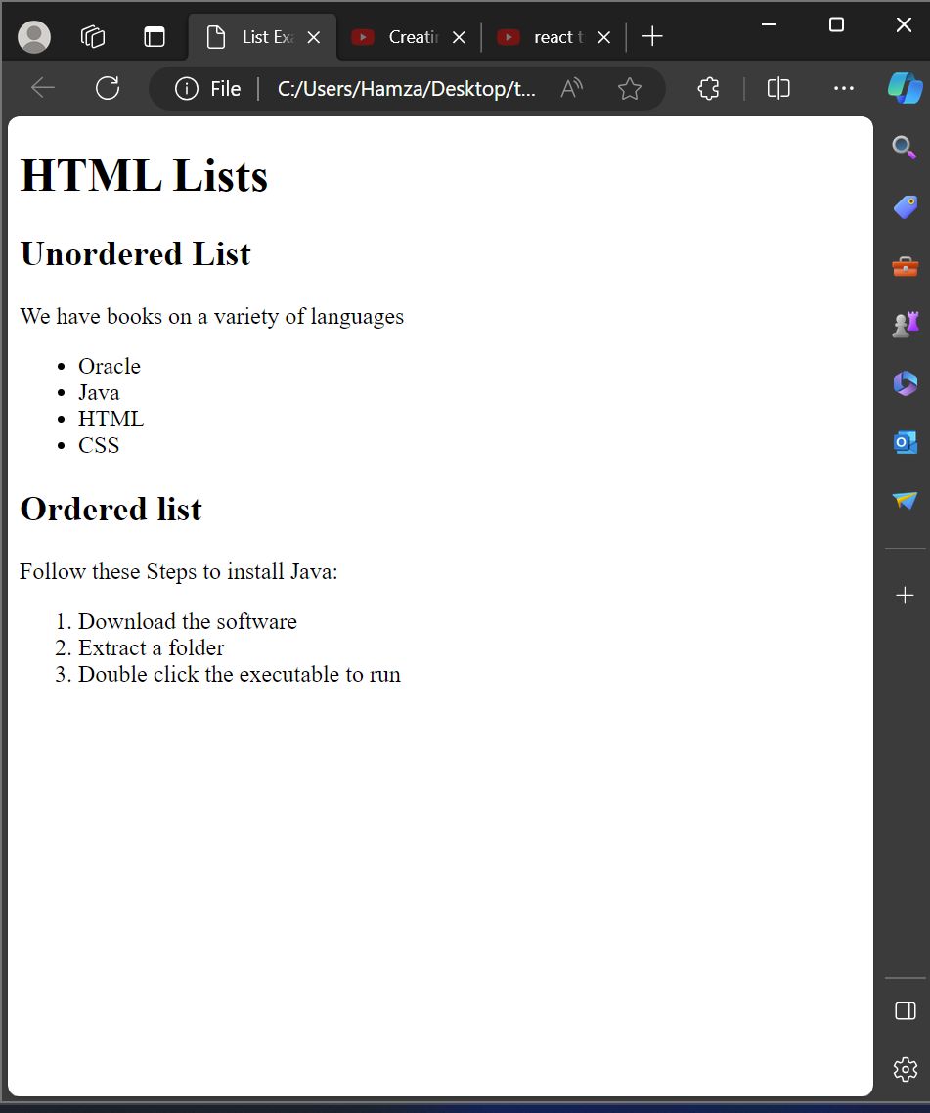

**Task 6:**

<!DOCTYPE html>

<html >

<head>

    <style>

        table , tr {

          border: 1px solid black;

          border-collapse: collapse;

        }

        td {

            border: 1px solid black;

          border-collapse: collapse;

          height: 20px;

          width: 100px;

          text-align: center;

          font-size: 20px;

        }

        </style>

    <meta name="viewport" content="width=device-width, initial-scale=1.0">

    <title>Rowspan Example with Height and Width</title>

</head>

<body>

    <table>

        <tr>

            <td rowspan="3" > April</td>

            <td ></td>

        </tr>

        <tr>

            <td ></td>

            <td ></td>

        </tr>

        <tr>

            <td ></td>

            <td ></td>

        </tr>

        <tr>

            <td ></td>

            <td ></td>

        </tr>

        <tr>

            <td ></td>

            <td ></td>

        </tr>

    </table>

</body>

</html>

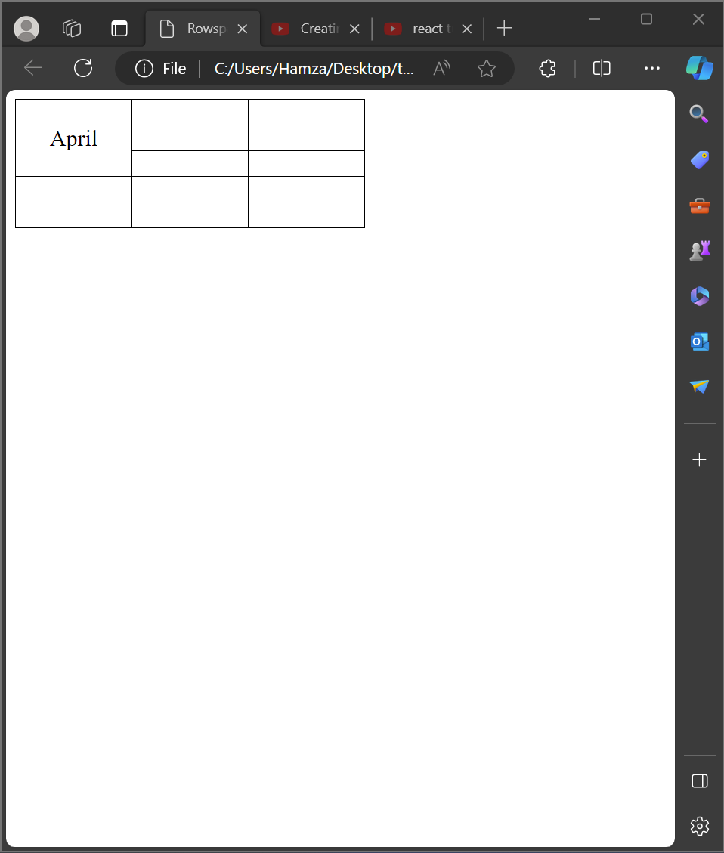

**Lab Task 7:**

<!DOCTYPE html>

<html >

<head>

    <style>

        table , tr {

          border: 1px solid black;

          border-collapse: collapse;

        }

        td {

            border: 1px solid black;

          border-collapse: collapse;

          height: 20px;

          width: 100px;

          text-align: center;

          font-size: 20px;

        }

        </style>

    <meta name="viewport" content="width=device-width, initial-scale=1.0">

    <title>Rowspan Example with Height and Width</title>

</head>

<body>

    <table>

        <tr>

            <td colspan="3"> 2022</td>

        </tr>

        <tr>

            <td ></td>

            <td ></td>

            <td ></td>

        </tr>

        <tr>

            <td colspan="2"  >fistaa</td>

        </tr>

        <tr>

            <td   ></td>

            <td ></td>

            <td ></td>

        </tr>

        <tr>

            <td ></td>

            <td ></td>

            <td ></td>

        </tr>

    </table>

</body>

</html>

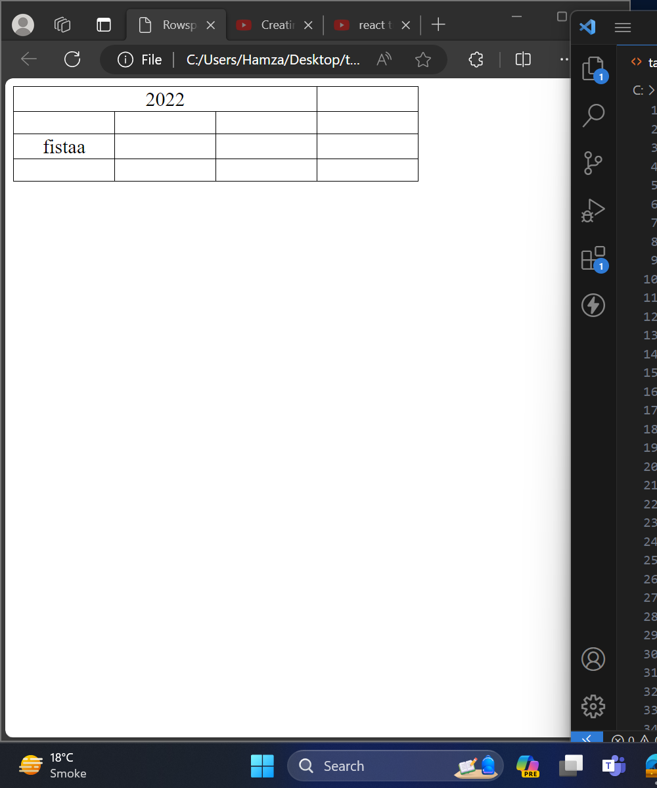

**Lab task 8:**

<!DOCTYPE html>

<html >

<head>

<meta name="viewport" content="width=device-width, initial-scale=1.0">

<title>Sign-up Form</title>

</head>

<body>

<form action="#" >

<label for="username">User Name:</label>

<input type="text" id="username" name="username" required><br>

<label for="email">Email:</label>

<input type="email" id="email" name="email" required><br>

<label for="password">Password:</label>

<input type="password" id="password" name="password" required><br>

<label for="confirm-password">Confirm Password:</label>

<input type="password" id="confirm-password" name="confirm-password" required><br>

<input type="submit" value="Submit">

<input type="reset" value="Reset">

</form>

</body>

</html>

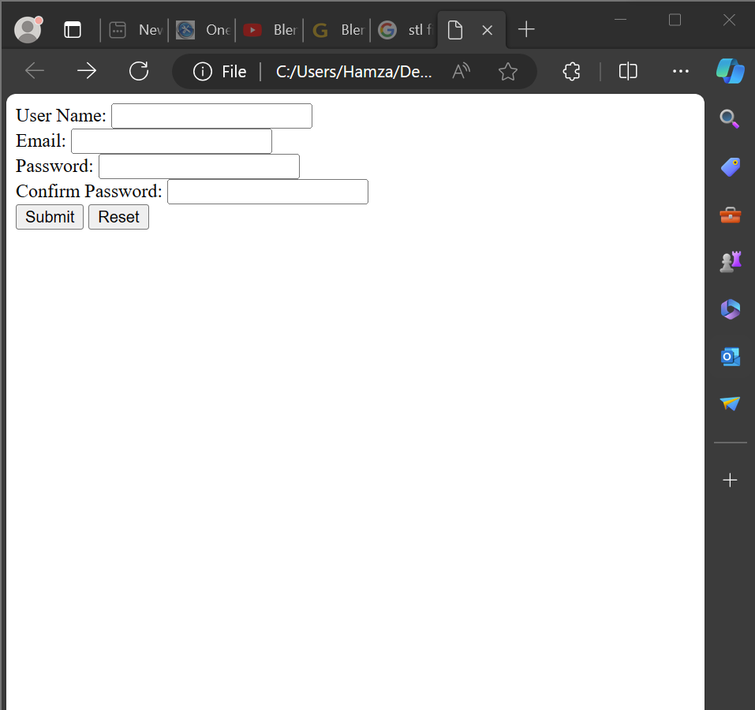

**Lab task 9:**

<!DOCTYPE html>

<html lang="en">

<head>

<meta charset="UTF-8">

<meta name="viewport" content="width=device-width, initial-scale=1.0">

<title>Task 9</title>

</head>

<body>

<h1>Pizza online</h1>

<h2>online order pizza</h2>

<form action="#" >

<table>

<tr>

<th>Topping</th>

<th>Select</th>

</tr>

<tr>

<td>Cheese</td>

<td><input type="radio" name="topping" value="cheese"></td>

</tr>

<tr>

<td>Pepperoni</td>

<td><input type="radio" name="topping" value="pepperoni"></td>

</tr>

<tr>

<td>Mushrooms</td>

<td><input type="radio" name="topping" value="mushrooms"></td>

</tr>

<tr>

<td>Olives</td>

<td><input type="radio" name="topping" value="olives"></td>

</tr>

<!-- Add more toppings as needed -->

</table>

<br>

<input type="submit" value="Place Order">

<input type="reset" value="Clear Form">

</form>

</body>

</html>

